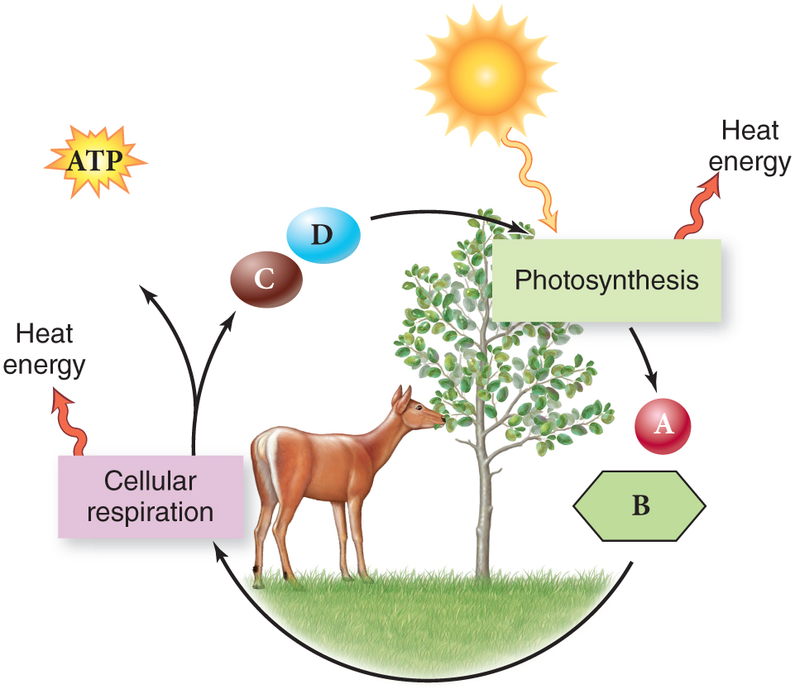
Lab 6: Photosynthesis in Leaf Discs

Purpose: To determine what ingredients are needed so that photosynthesis can occur and our leaves can float.

Procedure:
- Using a straw, cut 10 circular pieces from a spinach leaf
- Remove the plunger from a syringe and place the leaves in the syringe. Make sure all the leaves are at the bottom of the syringe
- Replace the plunger and push it down as far as possible, without crushing any leaves
- Pull 15 mL water into the syringe. Tap the syringe to suspend the leaves in the solution
- Holding a finger over the syringe opening, draw back the plunger to create a vacuum. Hold for 10 seconds while swirling the leaves in solution
- Release your finger. Repeat step 5 until all leaves sink in the solution
- Pour the leaves and water in a clear plastic cup. Add water to a depth of about 3 cm.
- Add 1 tsp. of dry carbon dioxide powder to the solution
- Place the cup under a lamp and start the timer. Record the number of leaves floating after each minute

Data: (Design a data table in which you measure the number of leaves floating after each minute, for 10 minutes)

Conclusion sentence starters:
During this lab, I observed…
I think this happened because…
This relates to photosynthesis because…
Errors could have occurred when…
I could improve this lab by…
To learn more about photosynthesis, I could…

Discussion Questions:
- Write the equation for photosynthesis
- What are the reactants of photosynthesis?
- How were the reactants of photosynthesis represented in this lab?
- What are the products of photosynthesis?
- How did we measure the products of photosynthesis in this lab?

Science 3: Presents Quantitative Data | •Student designs charts and tables in creative ways and in great detail | • Student designs charts and tables in conventional ways | • Students designs charts and tables with some organization | •Student lacks organization when creating charts, tables, or other representations OR does not organize information in a chart, table, etc.

Science 4: Conclusion and Discussion of Experiment | • Exceptionally makes objective conclusions, analyzes, and defends the data for trends and patterns using scientific concepts  • Insightfully relates or connects the activity and experimental results to concepts learned in class  • Thoughtfully critiques experiment by identifying sources of error and correctly explains in great detail how weaknesses in lab might have altered their data.  • Comprehensively suggests improvements and recommendations for further studying | • Makes objective conclusions, analyzes, and defends the data for trends and patterns using scientific concepts  • Relates or connects the activity and experimental results to concepts learned in class  • Critiques experiment by identifying sources of error and explains how weaknesses in lab might have altered their data  • Suggests improvements and recommendations for further studying | • Attempts to make objective conclusions, analyzes, and defends the data for trends and patterns using scientific concepts  •Attempts to relate or connect the activity and experimental results to concepts learned in class  •Somewhat critiques experiment by explaining how weaknesses in lab might have altered their data  •Attempts to make a few suggestions for improvements and recommendations for further studying | • Does not adequately make objective conclusions, analyze, or defend the data for trends and patterns using scientific concepts  • Does not adequately relate the activity and experimental results to concepts learned in class  • Does not adequately critique experiment by identifying sources of error or showing other weaknesses  • Does not offer suggested improvements and/or make recommendations for further

